KJSCE/IT/LYBTech/SEMVII/STQA/2022-23

**Batch:B1 Roll No.:1914078 Experiment No.:06**

**Aim:** To perform data driven testing using excel data.

**_______________________________________________________________________**

**Results: (Document printout as per the format)**

# Step 1: Create Java Project

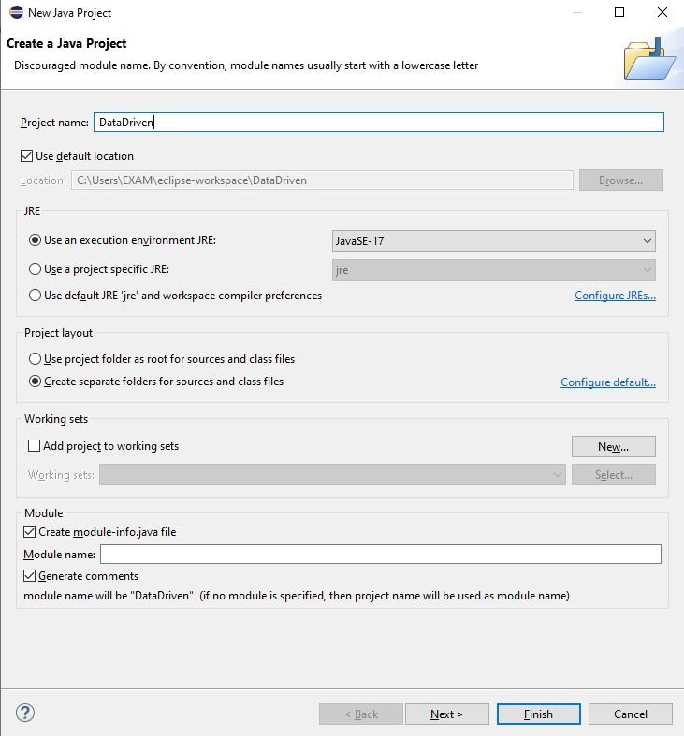

# Step 2: Download Apache POI .jar file

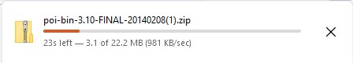

# Step 3: Adding plugins

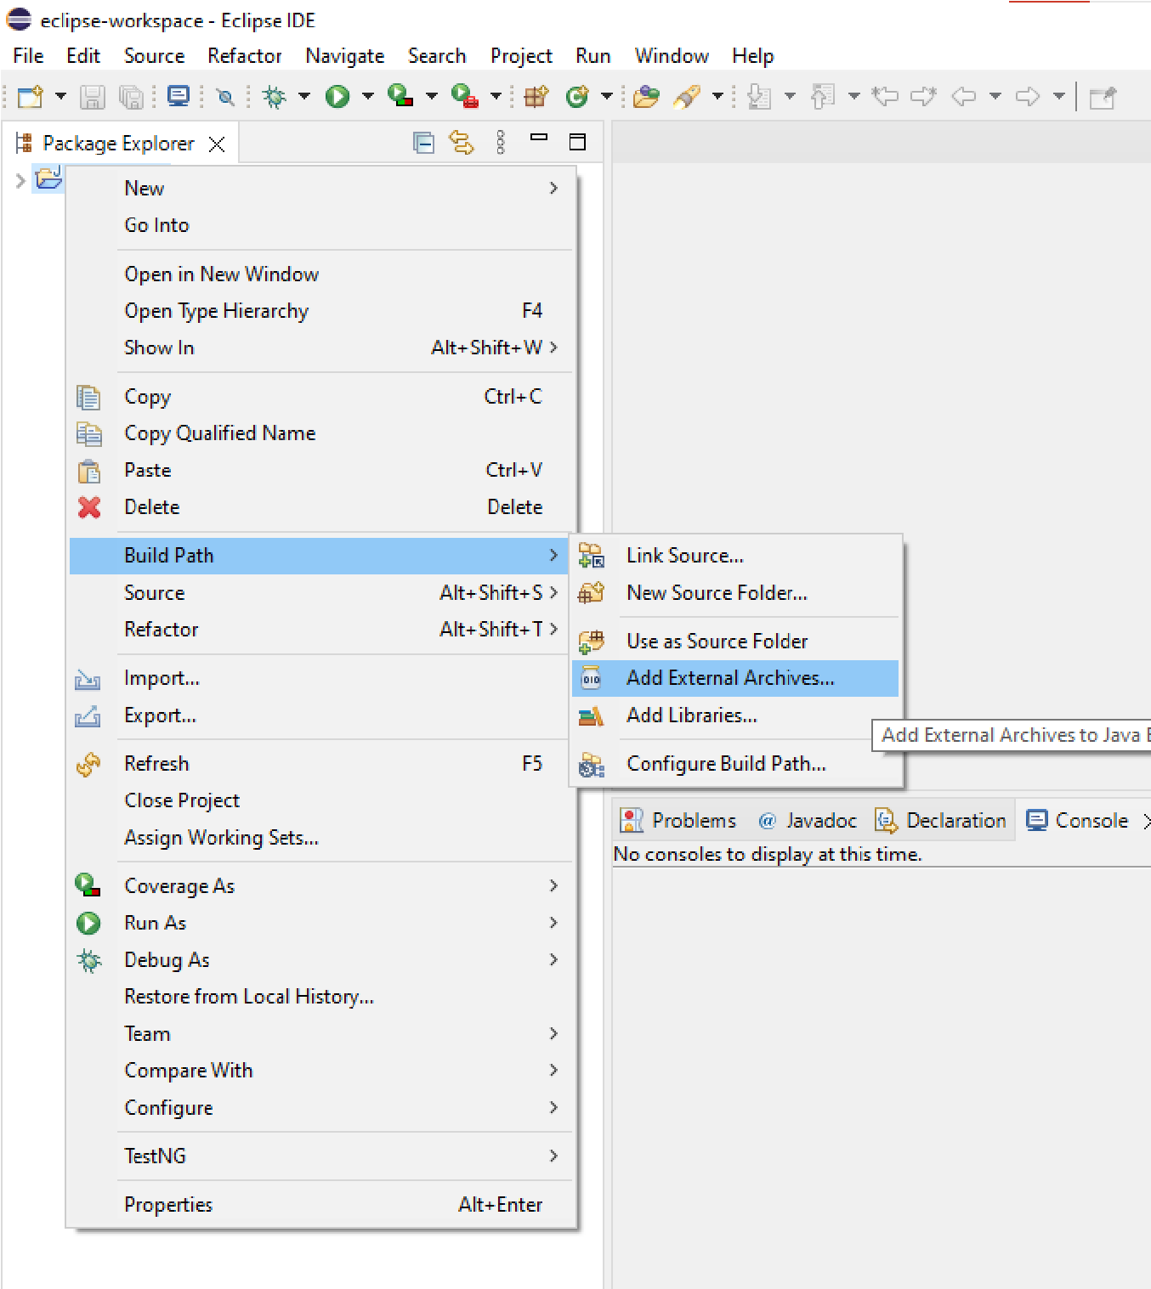

# Step 4: Extracting .jar file

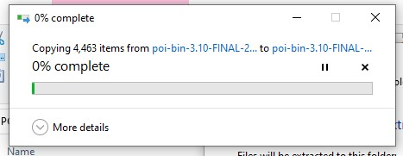

# Step 5: Creating input.xls file in Microsoft Excel

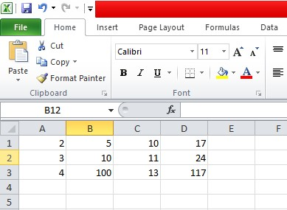

# Step 6: Write the Code in Eclipse to Access Input.xls and observe the output

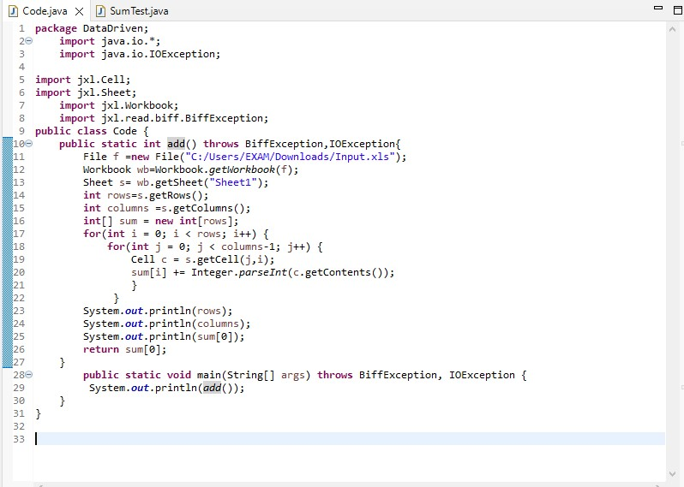

# Step 7: Writing the test case for the considered code

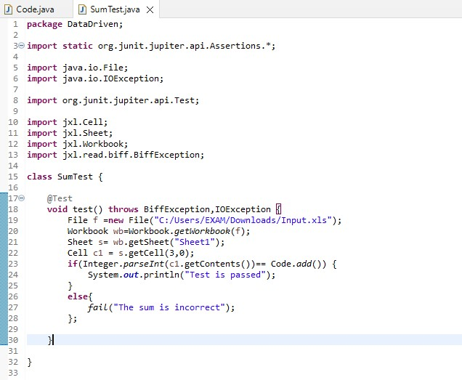

# Step 8: Running the tests

Case 1: Passing the test

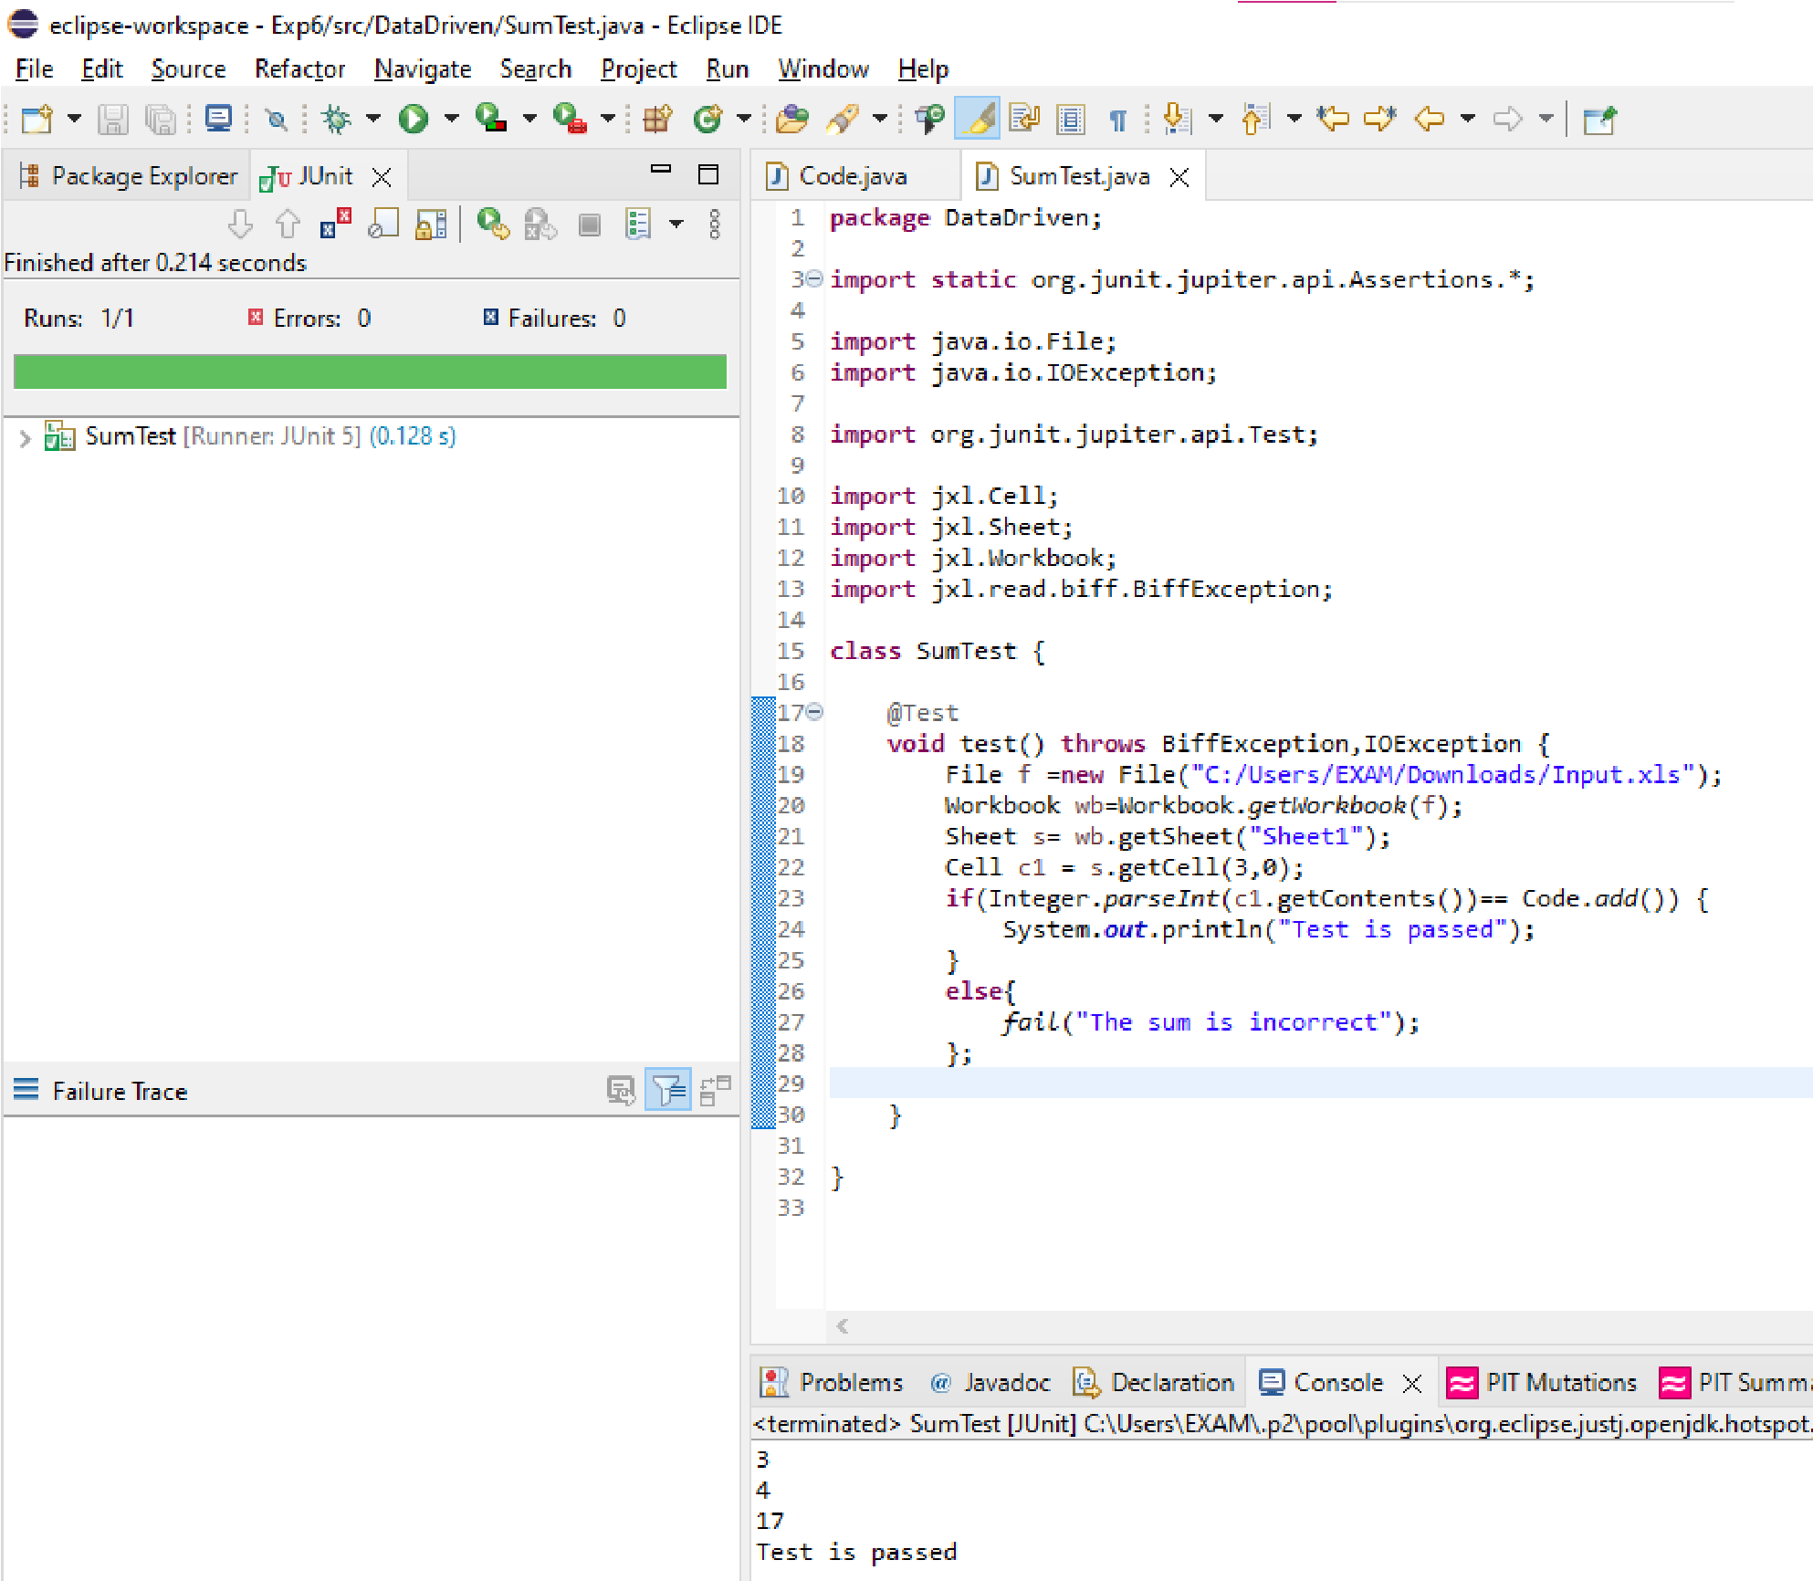

Case 2: Failed test case

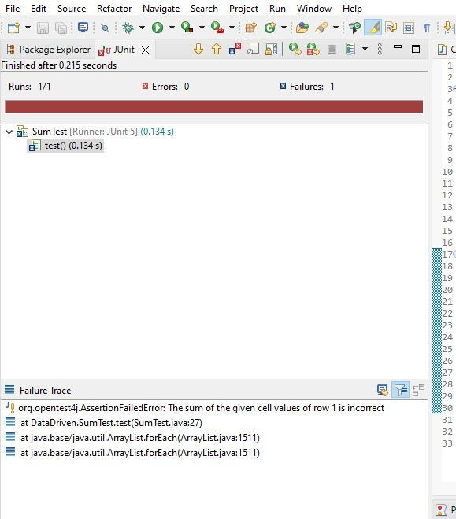

**Questions:**

**1.** Write is keyword driven testing.

**Keyword Driven Testing** is a scripting technique that uses data files to contain the keywords related to the application being tested. These keywords describe the set of actions that is required to perform a specific step.

A keyword-driven test consists of high and low-level keywords, including the keyword arguments, which is composed to describe the action of a test case. It is also called table-driven testing or action word based testing.

In Keyword Driven Testing, you first identify a set of keywords and then associate an action (or function) related to these keywords. Here, every testing action like opening or closing of browser, mouse click, keystrokes, etc. is described by a keyword such as openbrowser, click, Typtext and so on.

In Software Engineering, Keyword Driven Testing is done due to following reason

* Common components handled by standard library
* Using this approach tests can be written in a more abstract manner
* High degree of reusability
* The detail of the script is hidden from the users
* Users don’t have to use the scripting languages
* The test is concise, maintainable and flexible

# __________________________________________________________________________ Outcomes: CO3: Apply recent automation tools for software testing ______________________________________________________________________ Conclusion: (Conclusion to be based on outcomes)

We performed data driven testing using excel data and Eclipse. We implemented test cases for the program of addition cell values in the excel sheet. We implemented the test cases for multiple values in the excel sheet and observed the variations in result.